The Gold Ring

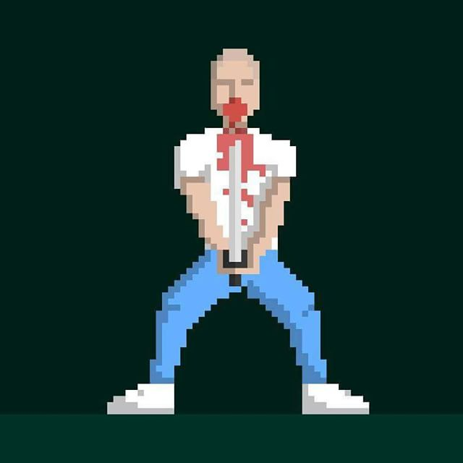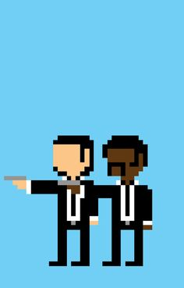The Gold Ring is a 2D platformer game aimed solely at mobile devices whose story is inspired by the events that take place to ‘Butch’ in Quentin Tarantino’s Pulp Fiction. The game will start with the main character heading towards a fight he has been paid to throw. At certain points along his journey he will face flashbacks to conversations with the mafia boss who has paid him to throw the fight and conversations with family members about the long history of the ring he was given as a boy that has been through multiple relatives. The game will shift into these relatives fighting in wars after they were introduced. Enemies faced on the way will be labelled ‘Pride’ as in a cut scene the mafia boss tells you to fight off pride. As in the film there will be no footage or gameplay of the fight, it will skip to the character running away from the fight. Now being chased by mafia members. If I have time I will continue with the story per the film. The art style for the game will be pixelated, similar style to what I am thinking are displayed below.

The reason I wanted to make this game is because I have always played platformers and Pulp Fiction has been one of my favourite films for a long time and I have always wanted to merge the two passions. As the film is a cult classic there is a readymade, large, fan base for this game to be aimed at which spans across age groups and genders making the game very marketable.

The mobile games industry grew by 21.3% on year in 2016 accounting for $36.9 billion making it the most popular device to buy games at 37% compared to 31% for console and 32% for PC gaming[1]. This growth in mobile is only predicted to grow over the next three years with some predicting that Chinese games revenues could double to $11.1 billion alone by 2019[2] (Takahashi, 2016). This leads me to believe that this game will most successful on the mobile platform.

Platformers have been an integral part of the gaming industry since the early 1980’s, with games like Donkey Kong (1981) and Canyon Climber (1982), and they have stayed prominent in the industry with Super Mario Run being in the top 100 grossing apps and #32 in overall free games at the time of writing (11/02/2017). Other recent releases include ‘Platform Panic’ in which your avatar is constantly moving and you must swipe left, right or up to keep him from hitting dangerous objects. I don’t think this constant movement is something that I want to include in my game as I would like a more structured, action, game rather than an arcade game. An example of a more structured game is ‘Swordigo’ where your character is battling the monsters that destroyed your master. The movement is controlled by pressing on the appropriate arrow button in accordance with direction you want to move / jump and other buttons for the attacking options. This is more like the way I would like to control the character.

1. [www.newzoo.com/resources](http://www.newzoo.com/resources)
2. www.venturebeat.com/2016/02/03/chinese-mobile-game-revenues-could-double-to-11-1b-by-2019/